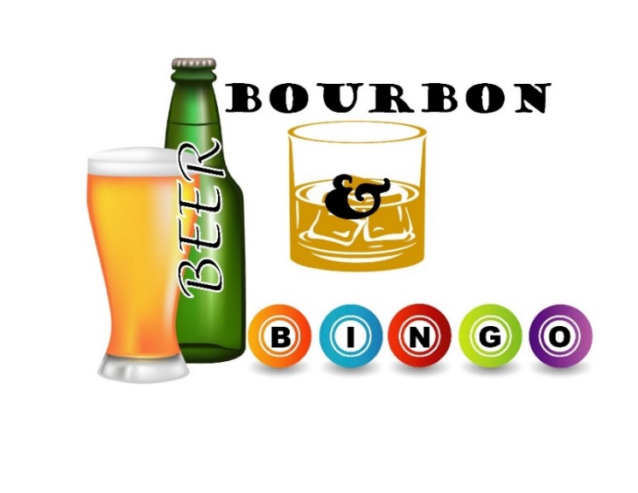

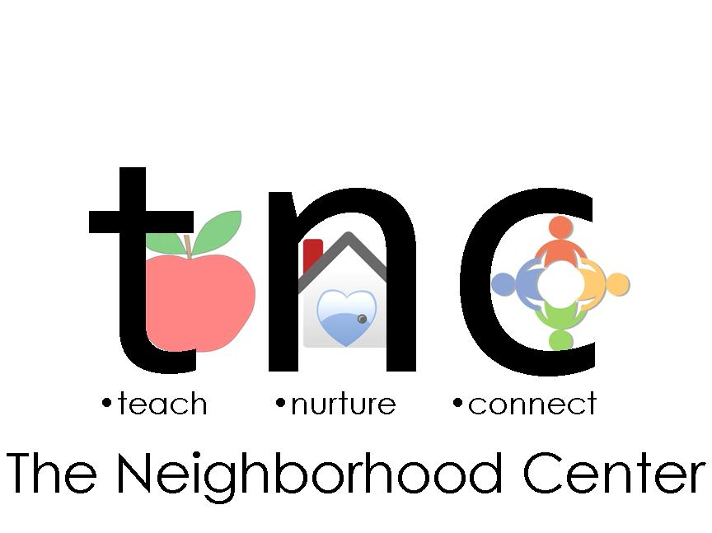

EIN 23-2039194

**Sponsorship Levels**

|  |  |
| --- | --- |
| **Barrel Sponsor – $5,000** | |
|  | * Name/Logo and Link on Event Website * Name in press materials and event signage * Name/Logo on Cover of Event Program * Full-Page Color Ad on Back Cover of Event Program * 8 complimentary VIP tickets at Reserved Table * Name/Logo on Event Promo Item and T-shirts as “Presenting Sponsor” * Grand Prize Coverall Game Sponsor |
| **Keg Sponsor – $3,000** | |
|  | * Name/Logo and Link on Event Website * Name in press materials and event signage * Full-Page Color Ad in Event Program * 8 complimentary VIP tickets at Reserved Table * Name/Logo on Event Promo Item and T-shirt * Wheel of Bourbon Game Sponsor (name/logo prominently displayed on game) |
| **Growler Sponsor – $1,000** | |
|  | * Name in press materials and event signage * Full-Page Color Ad in program book * 4 complimentary VIP tickets at Reserved Table * Name/Logo on Event T-shirts * Food Station Sponsor (banner with name/logo at food station) |
| **Yard Sponsor – $500** | |
|  | * Name on event signage * Full-page ad in program book * 4 complimentary tickets * Regular Bingo Game Sponsorship |
| **Stein Sponsor – $300** | |
|  | * ½ page ad in program book * Regular Bingo Game Sponsorship * 2 complimentary tickets |
| **Pint Sponsor - $100** | |
|  | * 1/4 page ad in program book * 1 complimentary ticket |

Program Book Advertisement

B&W: Full-Page $150 Half-Page $100 Quarter-page $75

Color: Full-Page $200 Half-Page $150 Quarter-page $125